**SALES PERFORMANCE AND COMPETENCY**

**Project Description:**

The project focuses on designing and implementing a **Sales Performance & Competency Dashboard** using data collected from three diverse business units—**SuperBee (Drone Production Unit), Apparel (Clothing Unit), and an EV Production Unit**. These three industries represent distinct domains but share a common requirement: tracking performance against set sales targets and understanding the role of customer feedback and competency in driving results.

In today’s competitive environment, organizations cannot rely only on sales numbers to assess success. Managers need a comprehensive view that connects **target achievement, customer satisfaction, and skill levels of employees**. This dashboard bridges that gap by visualizing how each unit performs in terms of sales and customer perceptions, and by identifying the relationship between competency and actual results.

The dataset used in this project was developed through structured data collection from the three business units. For each unit, data points such as **Target Sales, Planned Target Sales, Actual Sales, Customer Feedback, Ratings, and Suggested Improvements** were gathered. These inputs provide not only a financial perspective but also qualitative insights into what customer’s value and what areas require change. For example, in the drone production unit (SuperBee), feedback may highlight the need for enhanced battery life; in the clothing unit (Apparel), customers might emphasize style or durability; while in the EV production unit, ratings may focus on performance, range, or after-sales service. By combining such varied insights with sales figures, the dashboard becomes a powerful tool for decision-making.

The central objective of this project is to **compare actual sales against both planned and target sales** across the three industries. Planned target sales refer to the projections made at the beginning of the sales cycle, while target sales indicate the goals set for individual employees or teams. The variance between planned, target, and actual sales helps managers evaluate performance more effectively. A positive variance highlights strong execution, while a negative variance signals the need for corrective measures such as redesigning marketing strategies or improving product features.

The dashboard further integrates **competency and customer rating data** to uncover deeper insights. Competency levels of sales staff are measured through internal assessments and experience indicators, while customer ratings provide external validation of product quality and service delivery. By plotting competency against actual sales, managers can identify whether high competency levels consistently translate into better performance or whether other factors, such as customer preferences or regional demand, play a stronger role.

Additionally, the project captures **customer feedback on required changes** in each unit. This feedback loop is crucial for continuous improvement. For example, if EV customers consistently request faster charging solutions, the management team can prioritize product innovation in that direction. Similarly, clothing unit feedback on fabric quality or style trends can guide production planning and marketing strategies.

By presenting all these metrics in a **single, interactive dashboard**, the project delivers a **holistic view of sales performance**. Managers gain the ability to:

* Monitor target vs. actual performance at both team and individual levels.
* Identify top performers across units.
* Understand customer satisfaction trends and their impact on sales.
* Link employee competency with results to plan future training and hiring strategies.
* Make data-driven decisions for product improvements based on customer suggestions.

In conclusion, this project demonstrates how an integrated dashboard can transform raw data from multiple industries into actionable insights. By aligning **sales, competency, and customer feedback**, organizations like SuperBee, Apparel, and the EV production unit can improve efficiency, boost customer satisfaction, and achieve sustainable growth.

# ****Problem Statement****

The organization is facing challenges in effectively **tracking and analyzing sales performance across different business units**—Superbee (Drone Production), Appreal (Clothing), and the EV Production Unit. Although targets and planned sales are assigned, there is **limited visibility into how employees are performing against those targets**.

At the same time, **competency, training, and workplace factors** such as facilities, insurance, safety, and environment strongly affect performance, but managers lack a proper system to **connect these factors with actual results**.

Customer and employee **feedback is being collected**, but it is scattered and not systematically analyzed. As a result:

* Managers struggle to identify **high and low performers**.
* There is no clear link between **training received and sales outcomes**.
* Employee **feedback on issues like internet problems, need for more staff, or better guidance** is not translated into actionable insights.
* Planned vs. actual vs. target sales are not being compared effectively, leading to **gaps in performance evaluation**.

In short, the problem lies in the **lack of a unified dashboard** that combines **sales data, competency scores, employee experience, and feedback** to providea **360-degree view of performance and satisfaction.**

**OBJECTIVES:**

1. **To evaluate sales performance against planned and target sales**  
   – Compare actual sales results with both planned projections and assigned targets across all three units to identify performance gaps.
2. **To understand factors influencing productivity**  
   – Assess the impact of **experience, training, working environment, and facilities** on employees’ ability to meet targets.
3. **To evaluate organizational support systems**  
   – Examine how facilities (snacks, medical, rest area), insurance, and hygiene contribute to employee satisfaction and retention.
4. **To integrate employee feedback into decision-making**  
   – Collect and analyze employee suggestions such as need for guidance, staff availability, or technical improvements to identify areas of organizational improvement.
5. **To measure overall satisfaction and competency levels**  
   – Use ratings, training received, and feedback to assess workforce competency and align it with sales performance for better future planning.

# ****Graphs & Descriptions:****

1. Radar Chart (Top-Left)

Name: Ratings (overall) by Feedback

Inputs kept: Feedback categories (Electricity issues, Internet issues, Require holidays, Teamwork, Need training, Rest area, etc.)

Ratings (numerical values)

Why:

This shows multiple feedback parameters together so we can quickly see which areas (like internet, training, or rest areas) have the biggest concerns.

2.Table (Top-Center)

Name: Employee Feedback Table

Inputs kept: Employee Name

Feedback text

Why:To list direct employee feedback in detail for qualitative insights, complementing the sentiment and ratings.

3. Card (Top-Center, Right)

Name: Average of Sentiment

Inputs kept: Sentiment score (calculated from feedback text)

Why: To summarize the overall employee sentiment in a single, easy-to-read metric.

4. Bar Chart (Bottom-Left)

Name: Actual Monthly Sales by Training Received

Inputs kept: Training received (Yes/No)

Actual monthly sales value

Why: To measure the impact of training on sales performance.

5.Donut/Pie Chart (Bottom-Center)

Name: Actual Monthly Sales by Field

Inputs kept: Fields (Apparel, Electric Vehicle, SuperBee)

Actual sales value

Why: To show contribution of each product field to total sales, highlighting which field drives the most revenue.

6. Word Cloud (Bottom-Right)

Name: Sentiment Analysis Word Cloud

Inputs kept: Keywords extracted from feedback text (Internet, Rest, Guidance, Management, Holidays, etc.)

Why: To visually highlight the most common issues raised in feedback (bigger words = more frequent).

7. Mood Predictor (Top-Center, Bottom of Card)

Name: Sentiment Distribution

Inputs kept: Number of Negative, Neutral, Positive feedbacks

Why: To understand how feedback sentiment is spread across employees (not just the average).

8. Gender Filter (Top-Right)

Name: Gender-wise Segmentation

Inputs kept: Gender (Male/Female)

Why: To allow filtering of feedback and sales performance by gender for deeper insights.

In short:

Radar Chart: To compare multiple issues.

Table: To capture raw feedback.

Card: To show overall sentiment.

Bar Chart: To see training impact on sales.

Pie Chart: To compare sales contribution by field.

Word Cloud: To identify frequent feedback keywords.

Mood Predictor: To classify sentiment counts.

Gender Filter: To analyze gender-wise differences.

**1.Image Description (Clothing Unit – Apparel)**

This image captures the **production floor of the Apparel clothing unit**, where workers are engaged in garment stitching and finishing. The picture highlights the structured work environment with rows of sewing machines, fabric materials, and employees focused on production tasks.

It represents the **operational side of the clothing business unit**, which directly connects to sales performance and customer feedback. By documenting the production process, the image demonstrates how **efforts at the ground level influence customer satisfaction** (through product quality, stitching, and finishing), which is later measured in the survey and feedback data.

Including this picture in the project also validates the data collection process by showing the **source of feedback and ratings from the apparel production unit**.

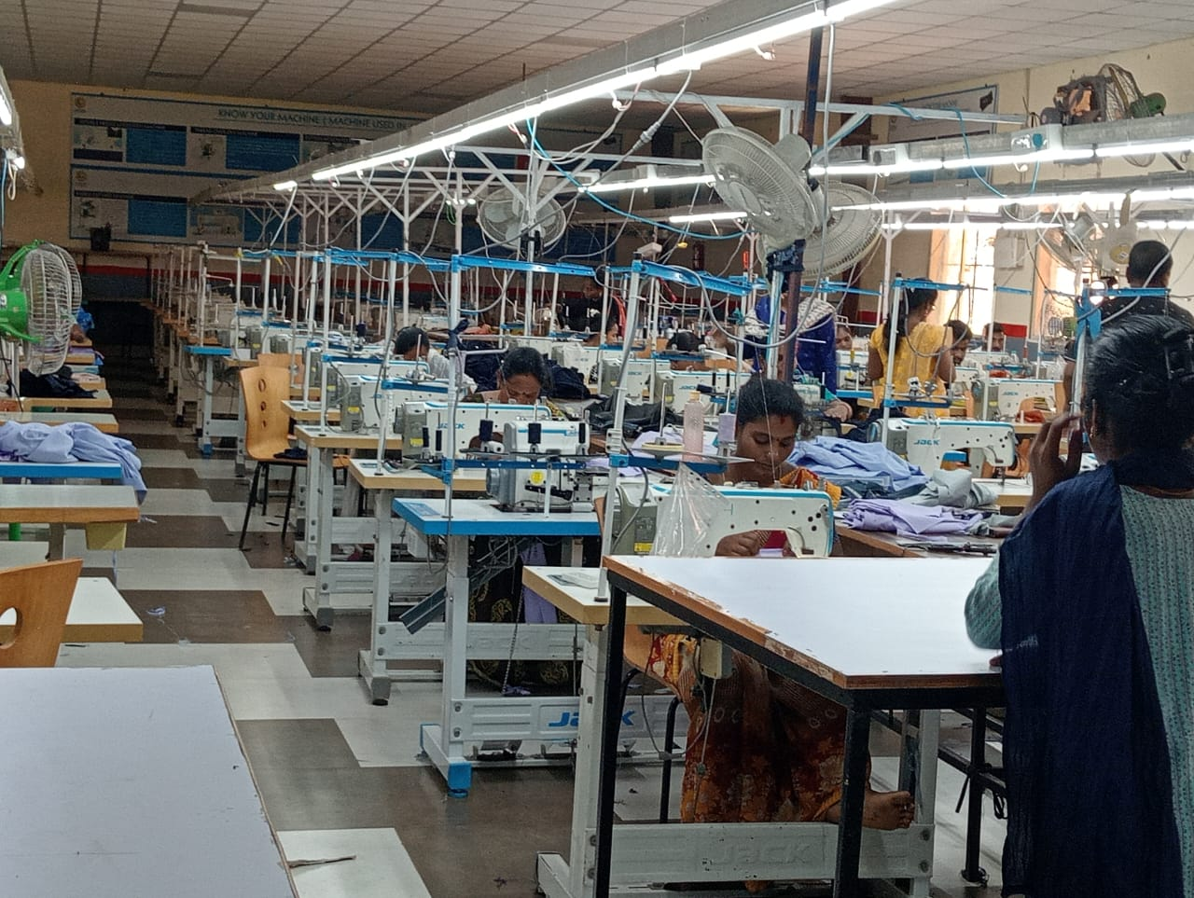

2. This image showcases the **assembly line of the Electric Vehicle (EV) production unit**, where different models of electric rickshaws and utility vehicles are being developed. The picture highlights partially assembled vehicles placed systematically on the production floor, ready for further manufacturing and testing.

The EV unit forms a critical part of the project dataset, as customer ratings and feedback collected here reflect concerns related to **vehicle design, performance, charging time, and durability**. By capturing the production environment, this image provides a direct connection between the **manufacturing process** and the **customer experiences** that influence sales performance.

It demonstrates how the EV unit contributes to both sales data and competency analysis, since employees’ skills in assembling and maintaining EVs directly affect product quality, customer satisfaction, and overall business performance.

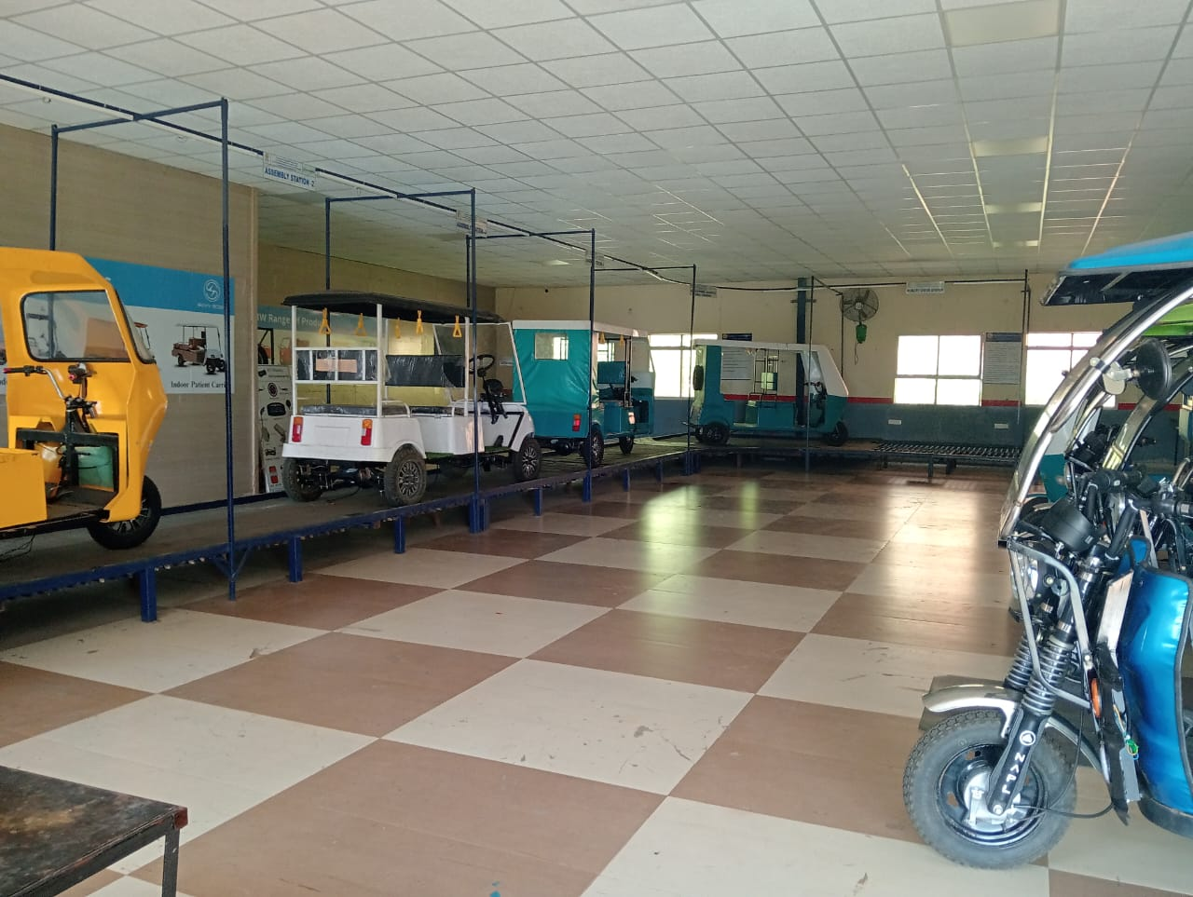

3. This image shows the **main entrance of SuperBee Aeronautics Pvt. Ltd.**, a specialized production and development unit focusing on drones and advanced aeronautical technologies. The facility is a hub for designing, testing, and manufacturing drones that cater to both industrial and commercial needs.

The drone production unit plays a crucial role in this project as it contributes significantly to the dataset on **sales, target achievement, customer ratings, and feedback**. Feedback from customers in this segment often focuses on aspects like **battery life, flight stability, camera quality, and durability**.

By including this image, the project establishes the authenticity of the data source and demonstrates how the **manufacturing and development setup** supports sales operations. It also highlights the importance of linking **competency of employees** (engineers, technicians, sales staff) with the actual **market performance of drone products**.

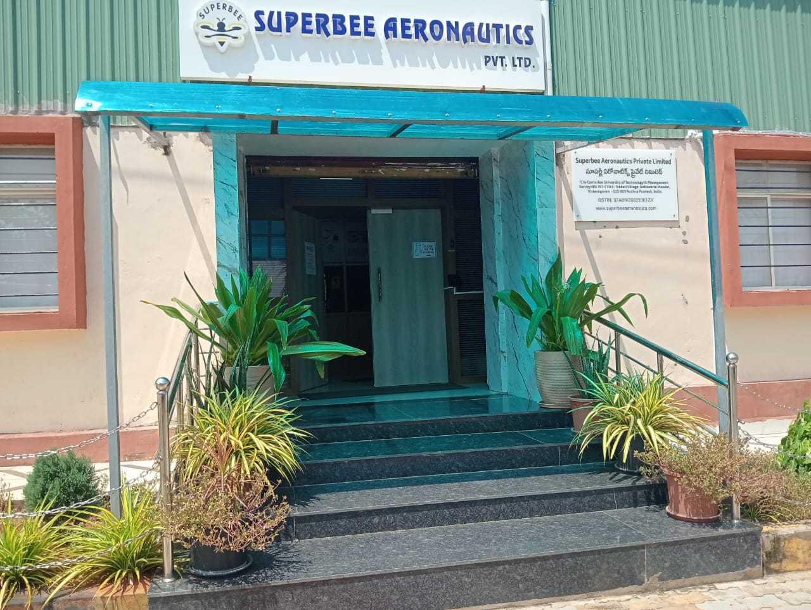

**CONCLUSION**:

The CUTM Sales Performance and Competency Analysis Dashboard provides a comprehensive view of employee feedback, sales performance, and competency development. The analysis highlights that internet and electricity issues, lack of training, and need for guidance are the most frequent concerns among employees. The sentiment score of 0.40 shows that feedback leans more toward the negative side, indicating areas for immediate improvement.

From the sales perspective, the dashboard shows that training has a significant positive impact on sales performance, as employees who received training generated higher revenue. Among different fields, SuperBee contributes the maximum share of sales (50.9%), followed by Electric Vehicles and Apparel.

Overall, the dashboard helps identify both employee-related issues (training, facilities, teamwork) and business-related insights (field-wise performance, training impact). By addressing employee concerns and strengthening training initiatives, the organization can improve both employee satisfaction and sales outcomes.